Name _____________________________________ Date____________
1.OA.3 Apply properties of operations as strategies to add and subtract. For example: If 8 + 3 = 11 is known, then 3 + 8 = 11 is also known. (Commutative property of addition.) To add 2 + 6 + 4, the second two numbers can be added to make a ten, so 2 + 6 + 4 = 2 + 10 =12. (Associative property of addition.) First grade students need not use formal terms for these properties.

Add in any order
(Ch3 Go Math)

For each problem below, write the addends in a different order.

3 + 4 = 7 _____ + _____ = _____

- 9 + 1 = 10 _____ + _____ = 10

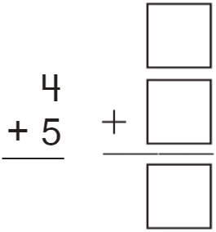
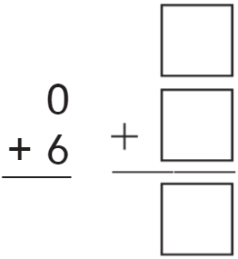
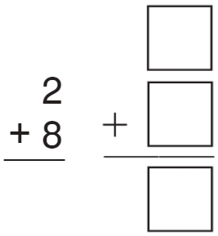
- 5.

Mastered Not Mastered
2nd try ______ 3rd try ______

