Name _____________________________________ Date____________
1.OA.1 Use addition and subtraction within 20 to solve word problems involving situations of adding to, taking from, putting together, taking apart, and comparing, with unknowns in all positions. For example, use objects, drawings, and equations with a symbol for the unknown number to represent the problem.

Add with pictures and objects to add to a part within 10 in a word problem. (Ch1 Go Math)

- There are 2 rabbits. 5 more rabbits join them. How many rabbits are there?
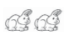
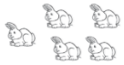

2 rabbits and 5 more rabbits _________ rabbits

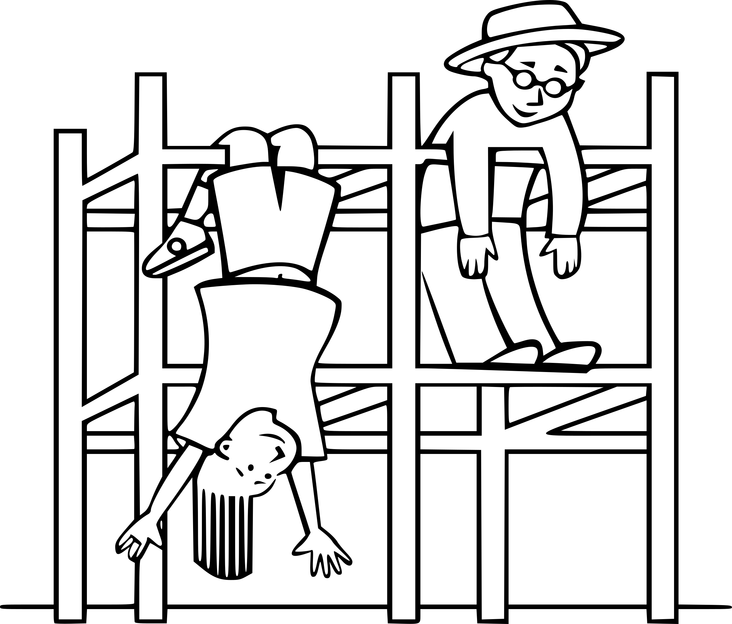
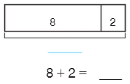

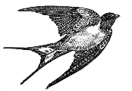
- 5 birds are flying in a group. 4 more birds join the group. How many birds are there now?
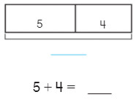

- There are 8 children in the park. 2 more children come. How many children are in the park?

Mastered Not Mastered
- Use to solve.
There are 3 flowers in a garden. 2 more flowers grow in the garden. How many flowers are in the garden?

_________ flowers

- 2 ducks are swimming in a pond. 2 more ducks come to swim. How many ducks are in the pond now?

_________ ducks

