Name _____________________________________ Date____________
1.OA.6 Add and subtract within 20. a. Use strategies such as counting on; making ten (for example, 8 + 6 = 8 + 2 + 4 = 10 + 4 = 14); decomposing a number leading to a ten (for example, 13 - 4 = 13 – 3 – 1 = 10 – 1 = 9); using the relationship between addition and subtraction (for example, knowing that 8 + 4 = 12, one knows 12 – 8 = 4); and creating equivalent but easier or known sums (for example, adding 6 + 7 by creating the known equivalent 6 + 6 + 1 = 12 + 1 = 13).
Decompose to a 10
(Ch4 Go Math)

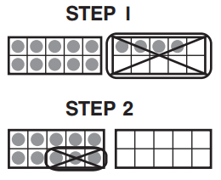
- What subtraction sentence does the model show?

10 – 4
10 – 4 – 3
14 – 4
14 – 4 – 3

- How does the model show 14 – 7? Choose the numbers that make the number sentences true. Circle numbers in the boxes.
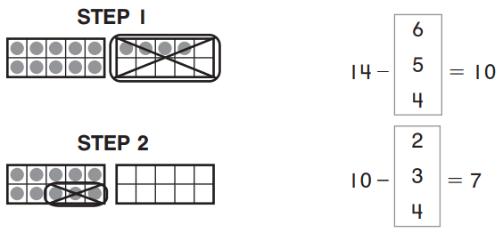
Mastered Not Mastered
2nd try ______ 3rd try ______
- What subtraction sentence does the model show?
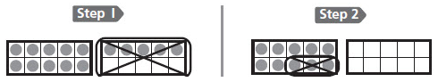

15 – 5 15 – 5 – 3
10 – 5 10 – 5 – 3

- Write the number sentence to show the steps in the model.
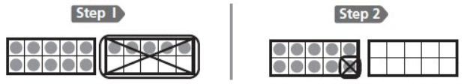

_____ – _____ – _____ = _____

- Which model shows 16 – 8?
