Name _____________________________________ Date____________
1.OA.3 Apply properties of operations as strategies to add and subtract. For example: …To add 2 + 6 + 4, the second two numbers can be added to make a ten, so 2 + 6 + 4 = 2 + 10 =12. (Associative property of addition.) First grade students need not use formal terms for these properties.
1.OA.6 Add and subtract within 20. a. Use strategies such as counting on; making ten (for example, 8 + 6 = 8 + 2 + 4 = 10 + 4 = 14); decomposing a number leading to a ten (for example, 13 - 4 = 13 – 3 – 1 = 10 – 1 = 9);…
Make a Ten
(Ch3 Go Math)

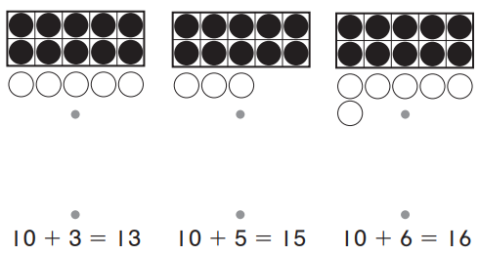
- Match the models to the number sentences.

- The model shows 9 + 2 = 11. Write the 10 fact that has the same sum.

_____ + _____ = _____

Mastered Not Mastered
2nd try ______ 3rd try ______
- The model shows 9 + 5 = 14. Draw to show how to make a 10 in the second frame. Write the number sentence to show the 10.



    

