Aa
a
are
and
again
all
around
away
any
ago
after
about
animal
another
above
answer

Bb
be
by
boy
buy
because
blue
began
better
build
brought
busy
brother
been
before

Cc
can
come
could
call
carry
caught
climb
color
children
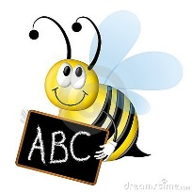

Dd
do
does
down
day
done
door

Ee
eat
every
eight
early
enough
eyes

Ff
for
fun
from
find
food
flew
found
four
full
fall
father
friend
front
favorite
few

Gg
go
good
green
grow
girl
give
great
guess
gone

Hh
he
has
here
have
help
her
happy
how
hard
heard

Ii
I
is
into
instead

Jj
jump

Kk
know
knew

Ll
like
look
little
live
laugh
listen
large
learn
love

Mm
my
me
make
move
many
more
money
mother
month

Nn
not
new
no
now
near
none
nothing

Oo
out
of
one
once
old
our
or
other
over
only
oh

Pp
play
pull
place
pretty
people
put
poor
picture
push

Qq
question

Rr
run
round
right

Ss
she
see
said
school
some
should
so
soon
small
start
sure
surprise

Tt
to
this
the
they
too
two
there
then
three
today
together
through
thought
toward
their
tomorrow

Uu
up
use
under
upon

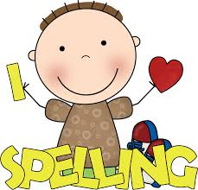
Vv
very

Ww
where
we
with
was
what
who
want
walk
way
why
water
work
warm
were
woman
would
write
wonder

Xx

Yy
you
year
your
young

Zz

