Name _____________________________________ Date____________
1.OA.1 Use addition and subtraction within 20 to solve word problems involving situations of adding to, taking from, putting together, taking apart, and comparing, with unknowns in all positions. For example, use objects, drawings, and equations with a symbol for the unknown number to represent the problem.

Add with pictures and objects to put together parts within 10 in a word problem. (Ch1 Go Math)

- There are 4 red leaves and 4 yellow leaves. How many leaves are there?

4 + 4 = _____ _________ leaves

- How many animals?
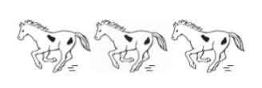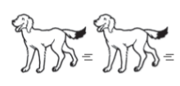
3 horses and 2 dogs _________ animals

- Use to solve.
There are 4 red crayons and 2 blue crayons. How many crayons are there?
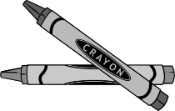

_________ crayons
Mastered Not Mastered
- Show two ways to make the number 9.

- There are 5 ladybugs and 4 butterflies in the garden. How many bugs are in the garden?

_________ bugs

