Scoot to Subtract Tens

Laminate and cut the 24 problem cards. They are numbered in the cube at the bottom of each card. Spread the cards out on the tables so there is one card at each chair. Give each student a scoot mat to record their answers. Students record the answer to each of the numbered problems as they move around the room. They can move around at their own pace and work within a time limit, or you can tell them to scoot every 10-15 seconds to the next card until all of the problem cards have been solved.

By Rachel Pehrson
31 – 10

1

92 – 40
25 – 20
3

2

84 – 20
4
50 – 10

5

73 – 30

7
45 – 20

6

61 – 10

8
90 – 20

9

18 – 10

11
57 – 30

10

39 – 10

12
86 – 40

13

77 – 30

15
67 – 10

14

58 – 20

16
14 – 10

17

65 – 30

19
80 – 40

18

47 – 20

20
25 – 10

21

74 – 10

23
40 – 20

22

34 – 20

24

Name __________________
SCOOT MAT
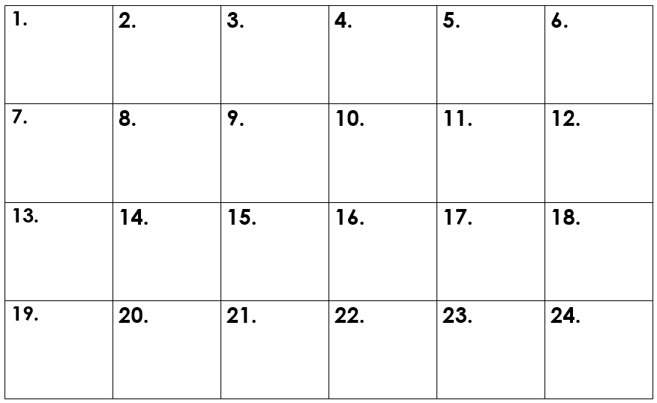
Record your answers in the same numbered box matching the number on the scoot problem card.

Name __________________
SCOOT MAT
ANSWER KEY
27
15
20
64
14
57
47
38
4
40
53
51
70
27
8
49
64
40
25
35
46
52
5
21

