**Wonders Sight Word**

**Seek n Find**

Give the students a copy of the page and a magnifying glass. Students seek for the small sight words and record them on the lines at the bottom as they find the words. They can either circle the word when they find it or color that part of the picture. After finding all the words, students may color the rest of the picture.

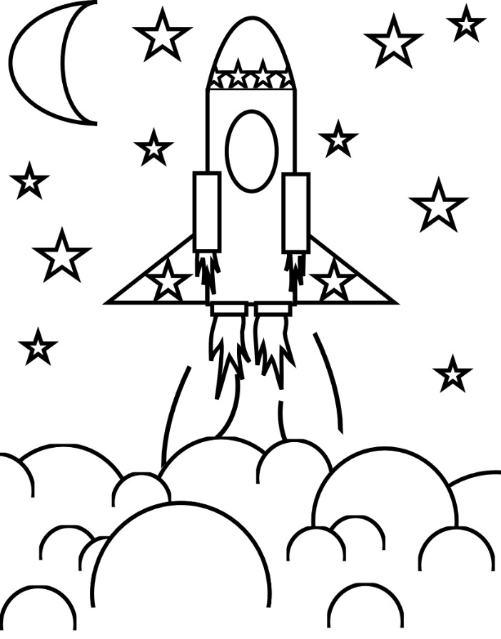Name ________________________________________

SW List 1

you

he

go

can

I

like

to

do

has

a

___________________________________

___________________________________

___________________________________

___________________________________

___________________________________

___________________________________

___________________________________

___________________________________

___________________________________

___________________________________

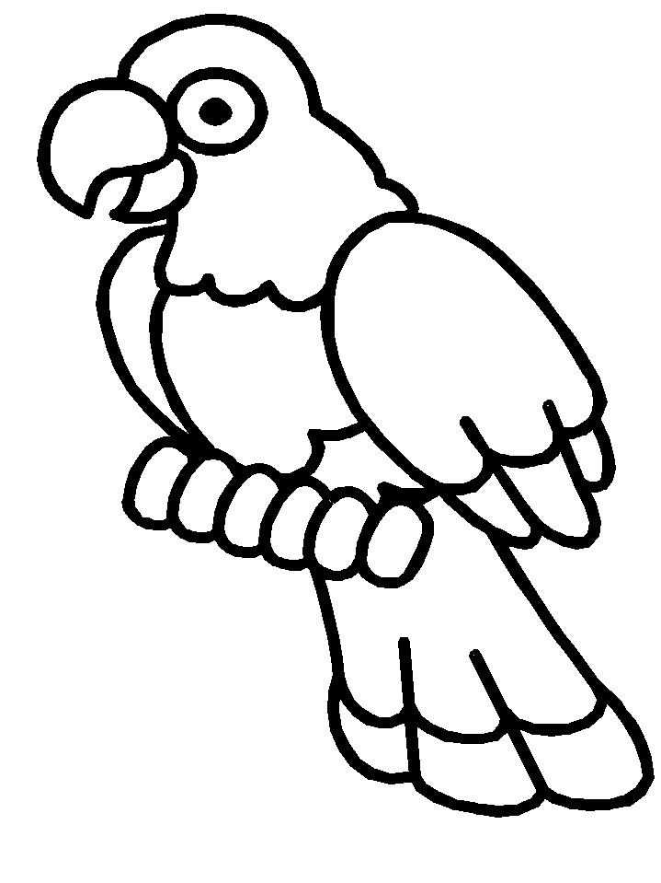Name ________________________________________

SW List 2

this

where

little

look

play

here

is

my

we

the

___________________________________

___________________________________

___________________________________

___________________________________

___________________________________

___________________________________

___________________________________

___________________________________

___________________________________

___________________________________

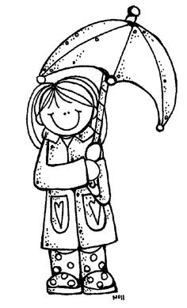Name ________________________________________

SW List 3

she

are

was

me

for

and

with

see

said

have

___________________________________

___________________________________

___________________________________

___________________________________

___________________________________

___________________________________

___________________________________

___________________________________

___________________________________

___________________________________

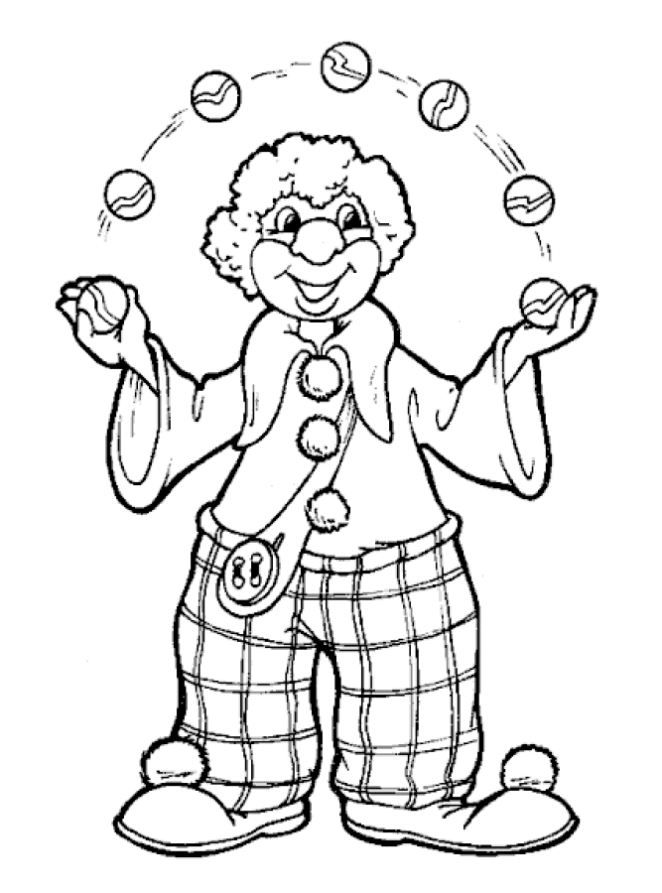Name ________________________________________

SW List 4

up

out

down

very

school

not

does

come

what

be

___________________________________

___________________________________

___________________________________

___________________________________

___________________________________

___________________________________

___________________________________

___________________________________

___________________________________

___________________________________

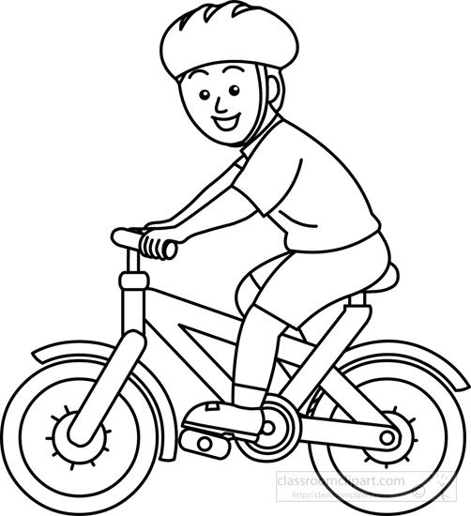Name ________________________________________

SW List 5

pull

fun

make

they

jump

too

move

good

two

run

___________________________________

___________________________________

___________________________________

___________________________________

___________________________________

___________________________________

___________________________________

___________________________________

___________________________________

___________________________________

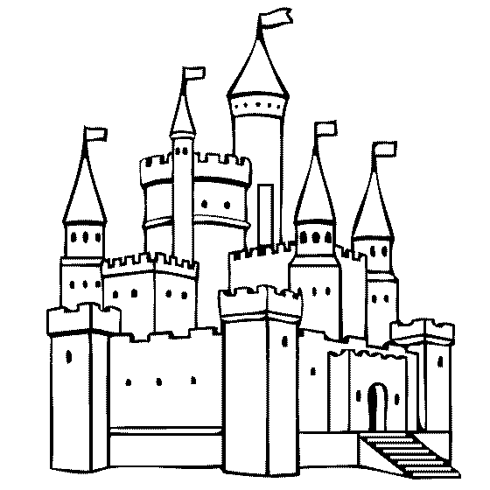Name ________________________________________

SW List 6

one

help

new

there

again

live

use

could

___________________________________

___________________________________

___________________________________

___________________________________

___________________________________

___________________________________

___________________________________

___________________________________

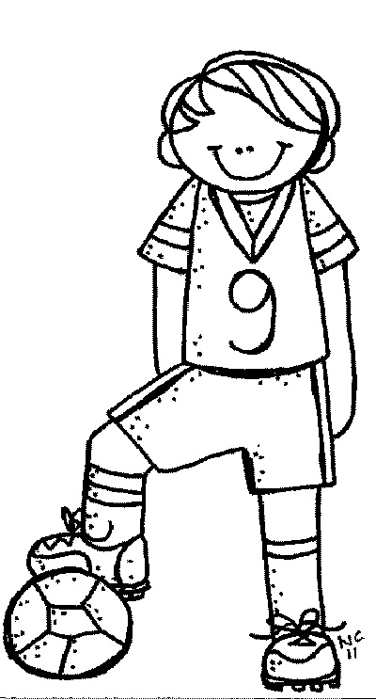Name ________________________________________

SW List 7

all

of

eat

who

three

then

no

under

___________________________________

___________________________________

___________________________________

___________________________________

___________________________________

___________________________________

___________________________________

___________________________________

Name ________________________________________

SW List 8

call

walk

day

want

by

her

many

place

around

___________________________________

___________________________________

___________________________________

___________________________________

___________________________________

___________________________________

___________________________________

___________________________________

___________________________________

___________________________________

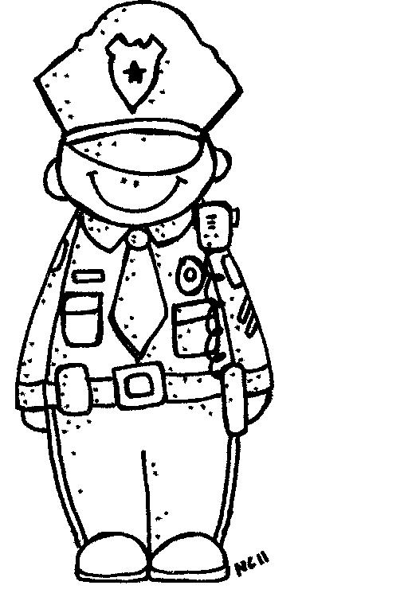Name ________________________________________

SW List 9

now

away

some

why

way

pretty

should

today

grow

green

___________________________________

___________________________________

___________________________________

___________________________________

___________________________________

___________________________________

___________________________________

___________________________________

___________________________________

___________________________________

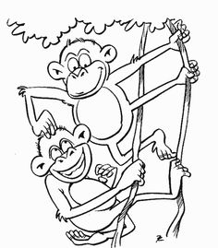Name ________________________________________

SW List 10

any

upon

ago

water

so

from

together

once

happy

boy

___________________________________

___________________________________

___________________________________

___________________________________

___________________________________

___________________________________

___________________________________

___________________________________

___________________________________

___________________________________

Name ________________________________________

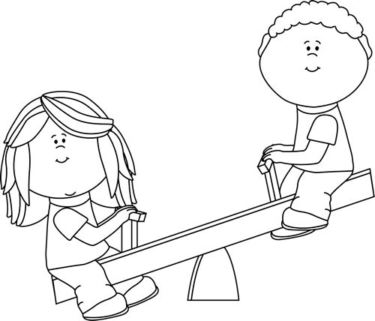SW List 11

old

how

after

girl

soon

work

people

buy

every

done

___________________________________

___________________________________

___________________________________

___________________________________

___________________________________

___________________________________

___________________________________

___________________________________

___________________________________

___________________________________

Name ________________________________________

SW List 12

our

or

blue

carry

into

animal

because

give

about

eight

___________________________________

___________________________________

___________________________________

___________________________________

___________________________________

___________________________________

___________________________________

___________________________________

___________________________________

__________________________________

Name ________________________________________

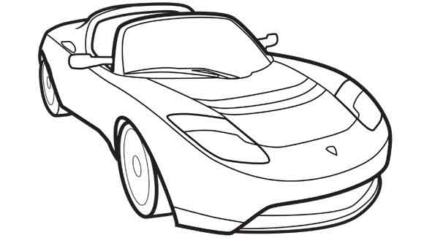SW List 13

find

start

small

other

food

over

more

warm

caught

flew

___________________________________

___________________________________

___________________________________

___________________________________

___________________________________

___________________________________

___________________________________

___________________________________

___________________________________

___________________________________

Name ________________________________________

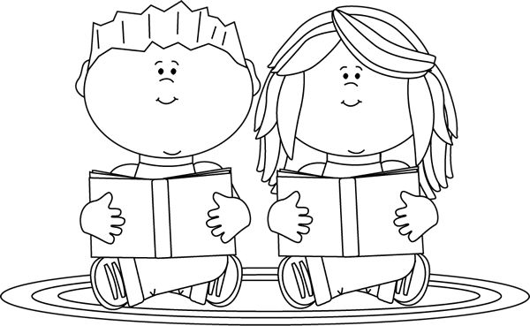SW List 14

write

were

hard

would

know

near

woman

listen

found

laugh

___________________________________

___________________________________

___________________________________

___________________________________

___________________________________

___________________________________

___________________________________

___________________________________

___________________________________

___________________________________

Name ________________________________________

SW List 15

large

climb

great

put

round

full

four

only

none

another

___________________________________

___________________________________

___________________________________

___________________________________

___________________________________

___________________________________

___________________________________

___________________________________

___________________________________

___________________________________

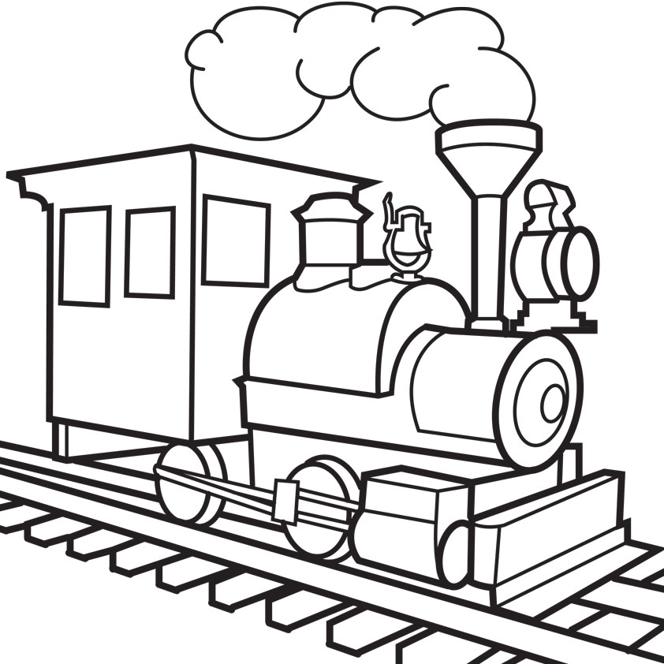Name ________________________________________

early

poor

color

right

better

SW List 16

began

guess

through

learn

sure

___________________________________

___________________________________

___________________________________

___________________________________

___________________________________

___________________________________

___________________________________

___________________________________

___________________________________

___________________________________

Name ________________________________________

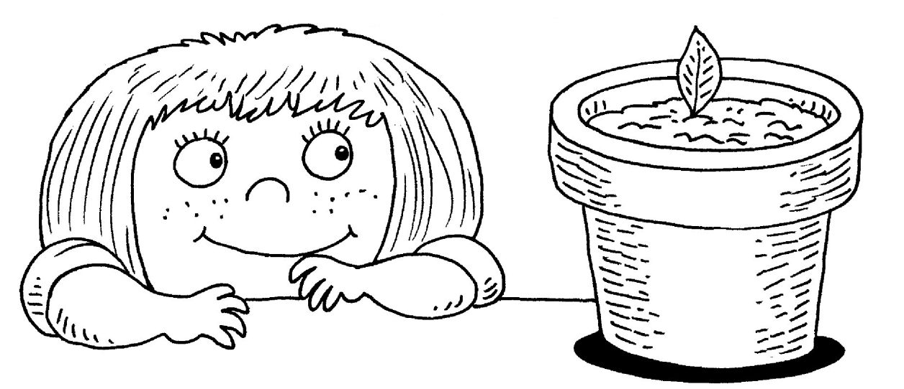SW List 17

knew

instead

oh

money

fall

thought

nothing

above

toward

build

___________________________________

___________________________________

___________________________________

___________________________________

___________________________________

___________________________________

___________________________________

___________________________________

___________________________________

___________________________________

Name ________________________________________

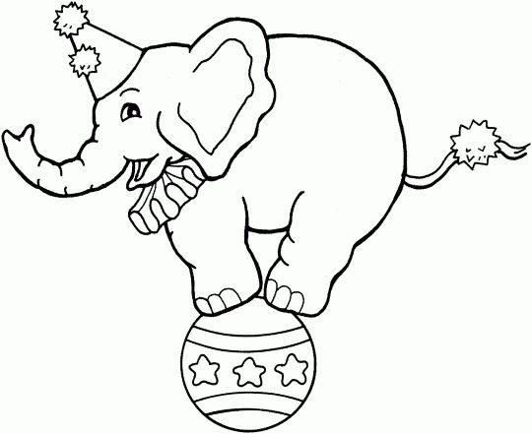SW List 18

busy

father

door

friend

answer

brought

eyes

enough

brother

love

___________________________________

___________________________________

___________________________________

___________________________________

___________________________________

___________________________________

___________________________________

___________________________________

___________________________________

___________________________________

Name ________________________________________

SW List 19

been

front

before

question

picture

mother

their

year

month

children

___________________________________

___________________________________

___________________________________

___________________________________

___________________________________

___________________________________

___________________________________

___________________________________

___________________________________

___________________________________

Name ________________________________________

SW List 20

your

surprise

push

heard

few

favorite

wonder

young

gone

tomorrow

___________________________________

___________________________________

___________________________________

___________________________________

___________________________________

___________________________________

___________________________________

___________________________________

___________________________________

___________________________________