Name _____________________________________ Date____________
1.OA.3 Apply properties of operations as strategies to add and subtract. For example: If 8 + 3 = 11 is known, then 3 + 8 = 11 is also known. (Commutative property of addition.) To add 2 + 6 + 4, the second two numbers can be added to make a ten, so 2 + 6 + 4 = 2 + 10 =12. (Associative property of addition.) First grade students need not use formal terms for these properties.

Subtract all or zero. (Ch2 Go Math)

- 6 ducks are in the pond. Then the six ducks swim away. How many ducks are in the pond now?
6 - 6 = ______ ______ ducks

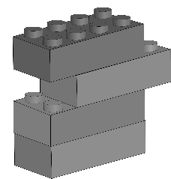
- There are 4 blocks in my tower. My brother takes all of the blocks. How many blocks do I have now?

4 - 4 = ______ ______ blocks

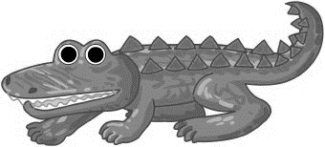
- There are 7 alligators in the water. Zero of them come out of the water. How many alligators are still in the water?

7 - 0 = _______ _______ alligators

Mastered Not Mastered
2nd try ______ 3rd try ______
- Use to solve.
There are 9 cows in a field eating grass. None of them go to the barn. How many cows are left in the field eating grass?

_________ cows

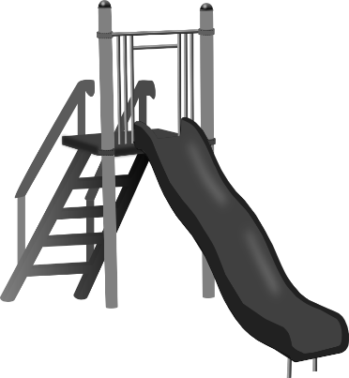
- 8 students are waiting to go down the slide. All of them have a turn to go down the slide. How many students are still waiting for their turn to go down the slide?

_________ students

