Name _____________________________________ Date____________
1.OA.1 Use addition and subtraction within 20 to solve word problems involving situations of adding to, taking from, putting together, taking apart, and comparing, with unknowns in all positions. For example, use objects, drawings, and equations with a symbol for the unknown number to represent the problem.

Subtract with pictures and objects to take apart groups within 10 in a word problem.
(Ch2 Go Math)

- There are 5 fish in a pond. 2 fish are red. The rest are yellow. How many fish are yellow?
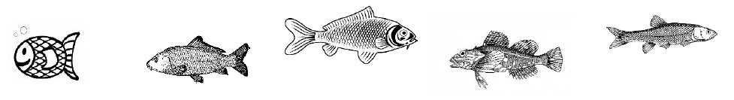

5 fish 2 red fish _________ yellow fish

- There are 3 frogs. 1 frog is in the pond. The rest are out of the pond. How many frogs are out of the pond?
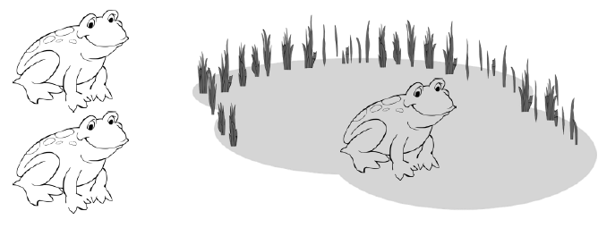
3 – 1 = _________

10 – 4 = _________ _________ frogs out of the pond

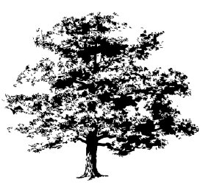
- There are 7 trees in the park. 3 trees are short. The rest are tall. How many trees are tall?

7 - 3 = _________ _________ tall trees

Mastered Not Mastered
2nd try ______ 3rd try ______
- Use to solve.

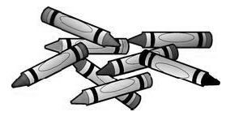
There are 8 crayons on my desk. 2 crayons are green. The rest are purple. How many crayons are purple?

? | 2
8

_________ purple crayons

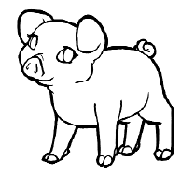
- There are 6 pigs on the farm. 3 of the pigs have brown spots. The rest are pink. How many pigs are pink?
3 | ?
6

_________ pink pigs

