Name _____________________________________ Date____________
1.OA.1 Use addition and subtraction within 20 to solve word problems involving situations of adding to, taking from, putting together, taking apart, and comparing, with unknowns in all positions. For example, use objects, drawings, and equations with a symbol for the unknown number to represent the problem.

Subtract with pictures and objects to take from a group within 10 in a word problem.
(Ch2 Go Math)

- There are 3 cats. 1 cat walks away. How many cats are there?

3 cats 1 cat walks away _________ cats

- There are 7 birds. 6 birds fly away. How many birds are there?

7 – 6 = _________

- There are 8 children in the park. 2 children went home. How many children are in the park now?
8 – 2 = _________

Mastered Not Mastered
2nd try ______ 3rd try ______
- Use to solve.
There are 3 flowers in a garden. I picked 2 flowers to give to my friend. How many flowers are left in the garden?

_________ flowers

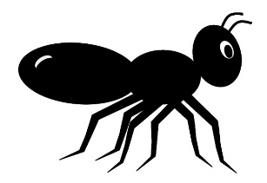
- 4 ants were going to a picnic. 2 ants went home. How many ants are still at the picnic?

_________ ants

