Name _____________________________________ Date____________
1.OA.1 Use addition and subtraction within 20 to solve word problems involving situations of adding to, taking from, putting together, taking apart, and comparing, with unknowns in all positions. For example, use objects, drawings, and equations with a symbol for the unknown number to represent the problem.

Subtract to compare in a word problem.
(Ch2 Go Math)

- There are 7 mice in the pet store. There are 5 pieces of cheese in the store. How many more mice are there than pieces of cheese?
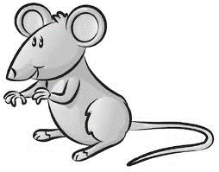

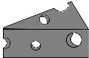

_________ more mice

- Robert has 10 pieces of candy. Lee has 4 pieces of candy. How many fewer pieces of candy does Lee have than Robert?

10 – 4 = _________ _________ fewer pieces of candy

- Dorothy has 3 keys. Milo has 8 keys. How many more keys does Milo have than Dorothy?
8
3 | ?

_________ more keys

8 – 3 = _________ Mastered Not Mastered
2nd try ______ 3rd try ______
- Use to solve.
My mom bought balloons for my party. 2 balloons are green. 6 balloons are red. How many more balloons are red than green?

? | 2
6

_________ red balloons

- There are 5 apples on the tree. 1 apple is on the ground. How many fewer apples are on the ground than on the tree?
? | 1
5

_________ apples on the ground

