Name _____________________________________ Date____________
1.OA.7 Understand the meaning of the equal sign, and determine whether equations involving addition and subtraction are true or false.
Is the Equation True or False
(Ch5 Go Math)

- Is the number sentence true or false?
12 – 6 = 10 + 6 true or false
3 + 4 = 3 + 3 + 1 true or false
5 + 2 + 2 = 13 – 4 true or false
16 – 8 = 5 + 4 true or false

- The table shows ways to make 14. Which shows a different way to make 14?
- 8 + 6
- 9 + 6
- 15 – 0
- 12 – 7
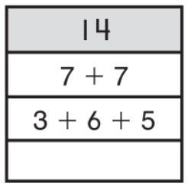
2nd try ______ 3rd try ______

Mastered Not Mastered
- What number makes the sentence true?

3 + 4 = 9 –

5 + 8 = 14 –

17 – = 3 + 4

2 + = 10 – 8

7 + 9 = + 1

