**Turn Talk**

**LOOK**

**and**

at your partner

**LISTEN**

to their words

**SPEAK**

so only your

partner can hear

**TURN**

back to the front

when done

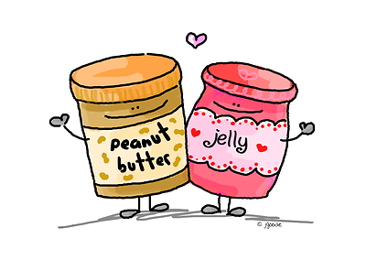

**WAIT**

quietly

**WAIT**