Name _____________________________________ Date____________
1.OA.1 Use addition and subtraction within 20 to solve word problems involving situations of adding to, taking from, putting together, taking apart, and comparing, with unknowns in all positions. For example, use objects, drawings, and equations with a symbol for the unknown number to represent the problem.
Use addition or subtraction within 20 to solve a word problem.
(Ch5 Go Math)

- Lisa bakes 6 muffins. Max bakes 8 more muffins than Lisa bakes. Which number sentence shows how to find the number of muffins Max bakes?

  - 8 – 6 = 2
  - 8 – 2 = 6
  - 6 + 8 = 14
  - 14 – 7 = 7

- Jason and Lucy eat 15 raisins. Jason eats 8 raisins. Which number sentence shows how to find the number of raisins Lucy eats?

  - 15 + 8 = 23
  - 9 + 6 = 15
  - 5 + 5 = 10
  - 15 – 8 = 7

- Mr. Stuart buys 11 erasers. He gives some erasers away. He has 7 erasers left. How many erasers did he give away?
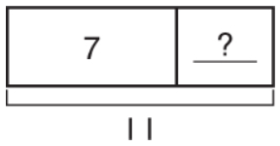
He gave away ______ erasers.

Mastered Not Mastered
2nd try ______ 3rd try ______
- Mitchell finds 6 shells on the beach. Now he has 13 shells. How many shells did Mitchell start with?
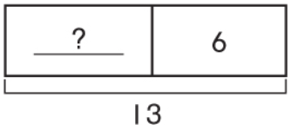
He started with _____ shells.

- Alba solves this subtraction sentence.

15 – 7 =

Write an addition sentence Alba can use to check her subtraction.

_____ _____ _____

